Qatar University  College of Engineering  Dept. of Computer Science & Eng. | Software Engineering  CMPS 310 - Lab

Lab 10 Implementation and Unit Testing
Supporting tools - Eclipse, JUnit 5, SpotBugs and SonarQube for IDE | 2 hours 30 minutes
Part A is guided practice and is not submitted. Part B is individual assessed work. Allow 10 minutes for setup, 45 for Part A, 85 for Part B and 10 for submission.
Before class, install JDK 17 and Eclipse. Importing a project does not install its analysis plugins. In Eclipse:
1. Choose Help > Eclipse Marketplace. Search for SpotBugs, click Install and complete the installation wizard.
2. Search for SonarQube for IDE (formerly SonarLint) and install the Eclipse plugin. Restart Eclipse when prompted. No SonarQube server connection is needed for this lab.
3. Reopen Marketplace and confirm both plugins show Installed. JUnit 5 is a project library; check it during the setup below.

Learning objectives
- Trace an implementation, including an abstract class and its subclasses, to the class and sequence diagrams of Labs 7 and 8.
- Derive test cases with input data and expected results from the steps and alternative flows of a use case specification.
- Automate test cases with JUnit 5 and use failing tests to locate and correct defects.
- Use SpotBugs and SonarQube for IDE to find defects that the tests missed, and decide whether each warning needs a fix.
Course learning outcome: CLO 6 - Design, implement, test and present a software system in a group. This lab prepares the testing evidence required in Milestone 2.

Implementation and Testing
Implementation turns the design into code. Tests check that code against the specification; static analysis checks for defects without running it. Choose tests that cover rules, alternative flows and boundaries.
Term | Meaning in this lab
Unit test | Checks one class or operation on its own, such as PrintJob.calculateCost().
Functional test | Checks a use case flow against its specification, such as UC001 alternative flow 5.a.
Test case | States what is being tested, the source requirement, inputs or actions, and the expected result. After execution, record the actual result and Pass or Fail.
Boundary value | A value at or next to a limit: 50 and 51 copies, or the exact auction end time.
Stub | A simple replacement for an external system, so that a test does not depend on it. A stub replaces PAS in Part A.
Static analysis | Examines the code without running it and reports likely defects.

JUnit 5 element | Use
@Test | Marks a test method. Each test method checks one test case and is independent of the others.
@BeforeEach | Runs before every test method, for example to create fresh objects.
assertEquals(expected, actual, delta) | Compares two double values within the tolerance delta, for example 0.001.
assertEquals(expected, actual) | Compares other values, such as int, String and enum values.
assertTrue, assertFalse, assertNull | Checks a condition or a missing value.
assertThrows(Exception.class, () -> ...) | Passes only if the code throws that exception.

Set up the project - 10 minutes
1. Download PrintShopLab10 from the course repository. In Eclipse, choose File > Import > General > Existing Projects into Workspace, then select the archive or extracted folder. IntelliJ users open the extracted folder.
2. Check that the JRE System Library is JavaSE-17 (JDK 17). In Properties > Java Compiler, enable project specific settings and set compliance to 17. Apply and accept the rebuild.
3. Check that src and test contain the supplied packages and classes. Check that JUnit 5 is on the build path; if missing, use Build Path > Add Libraries > JUnit > JUnit 5.
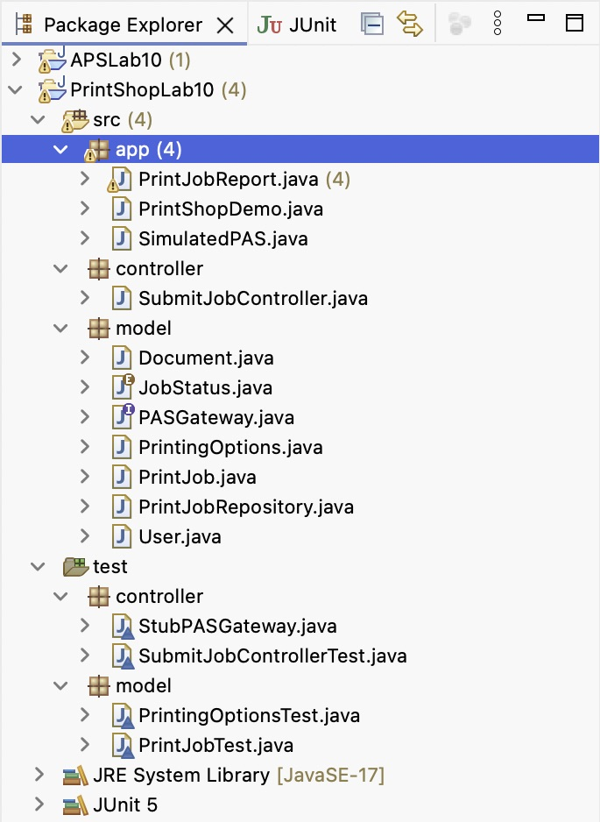
Figure 1 PrintShopLab10 project structure

If you use IntelliJ IDEA
The code and tests are the same in both IDEs. Use these equivalents for the Eclipse steps in this handout.
Eclipse step | IntelliJ IDEA equivalent
New > Source Folder test | Create the folder test, then right-click it > Mark Directory as > Test Sources Root.
Build Path > Add Libraries > JUnit 5 | Click @Test, press Alt+Enter and choose Add 'JUnit 5' to classpath.
Source > Generate Constructor / Getters | Code > Generate (Cmd+N on macOS, Alt+Insert on Windows).
Run As > Java Application | Click the green arrow next to main().
Run As > JUnit Test | Right-click the test folder > Run 'All Tests'.
SpotBugs and SonarQube for IDE from Eclipse Marketplace | Settings > Plugins > Marketplace: install SpotBugs and SonarQube for IDE. Code > Inspect Code also reports most defects.

Part A QU Print Shop - Guided practice - 45 minutes
Work through A.1 to A.4 with the instructor. The code implements the Lab 8 design of UC001 Submit print job. Lab 10 adds two rules that the earlier Print Shop labs did not need:
- Price list: QAR 0.25 per black-and-white page and QAR 1.00 per colour page, for each copy. Double-sided printing has a 10% discount.
- A job has 1 to 50 copies, and a document has at least one page.

A.1 Explore the implementation and run the demo
Class | Design source and Lab 10 note
PrintJob | Lab 7 attributes and calculateCost(); Lab 8 queue(). Status stays null until the job is queued.
PrintingOptions, User, JobStatus | Lab 7. Student and StaffMember are not needed here.
Document | Lab 10 refinement: the cost needs the number of pages, so the document becomes a class.
PASGateway | Lab 7 operation checkCredit(), written as an interface so that a test can replace PAS.
PrintJobRepository, SubmitJobController | Lab 8 Figure 1: the controller creates the job, asks for its cost, checks credit, then queues and saves it.

Open src/controller/SubmitJobController.java and trace how a job is submitted. Find calculateCost() in src/model/PrintJob.java. Run app.PrintShopDemo (Run As > Java Application): the QAR 5.00 job is accepted; the QAR 27.00 job is rejected because PAS holds only QAR 20.00.
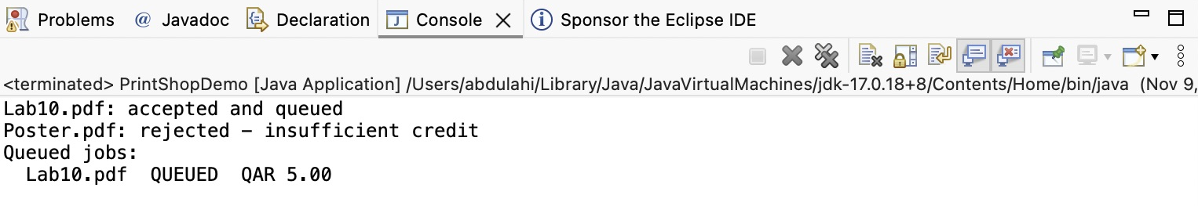
Figure 2 PrintShopDemo output

A.2 Design test cases from the specification
The demo shows two submissions, which you judge by reading console output. It illustrates TC-A7 and TC-A8 and uses the TC-A1 cost calculation. It does not try every case, such as zero copies. Here we define the checks; in A.3, JUnit automates them so they can be repeated after code changes.
All eight cases below test UC001 Submit print job (Appendix 1) and the pricing and copy-limit rules stated in Part A. This is a worked example; in Part B you design your own cases. Derive expected results from requirements before running the code.
ID | What we are testing | Requirement source | Input or action | Expected result
TC-A1 | Calculate black-and-white, single-sided cost | Pricing: QAR 0.25 per page per copy | 10 pages; 2 copies; black-and-white; single-sided | Cost QAR 5.00
TC-A2 | Apply the colour rate and duplex discount | Pricing: QAR 1.00 per page; 10% duplex discount | 10 pages; 1 copy; colour; double-sided | Cost QAR 9.00
TC-A3 | Set status when a job is queued | UC001 step 6; initial status in this implementation | Create a job, inspect status, then call queue() | Initially null; after queue(), QUEUED
TC-A4 | Reject zero copies | Copies rule: minimum 1 | Create options with 0 copies | Throw IllegalArgumentException
TC-A5 | Accept the maximum copy count | Copies rule: maximum 50 inclusive | Create options with 50 copies | Options created; getCopies() returns 50
TC-A6 | Reject a count above the maximum | Copies rule: maximum 50 | Create options with 51 copies | Throw IllegalArgumentException
TC-A7 | Accept, queue and save a funded job | UC001 steps 4–7 | Submit TC-A1 job; PAS stub reports sufficient credit | Return true; PAS asked about QAR 5.00; one QUEUED job saved
TC-A8 | Reject a job with insufficient credit | UC001 alternative flow 5.a | Submit a job; PAS stub reports insufficient credit | Return false; no job saved

A.3 Automate the tests with JUnit
Open test/model/PrintJobTest.java in PrintShopLab10. The supplied tests are worked examples: study their inputs and assertions, run them, then investigate failures. @BeforeEach prepares fresh objects before each @Test method. JUnit runs these methods; no main() method is needed. Test names describe expected behaviour, not the result of the latest run.
In assertEquals(5.00, job.calculateCost(), 0.001), 5.00 is expected, calculateCost() supplies the actual result, and 0.001 is the allowed absolute difference. This small tolerance accommodates floating-point rounding.
Also inspect test/model/PrintingOptionsTest.java and test/controller/SubmitJobControllerTest.java. test/controller/StubPASGateway.java replaces PAS and records the amount requested.
1. To run one class, right-click it > Run As > JUnit Test. PrintJobTest runs three tests, which should pass. To run all cases together, right-click the project or test folder > Run As > JUnit Test. Expect 8 runs, 2 failures (TC-A4 and TC-A6), and 0 errors.
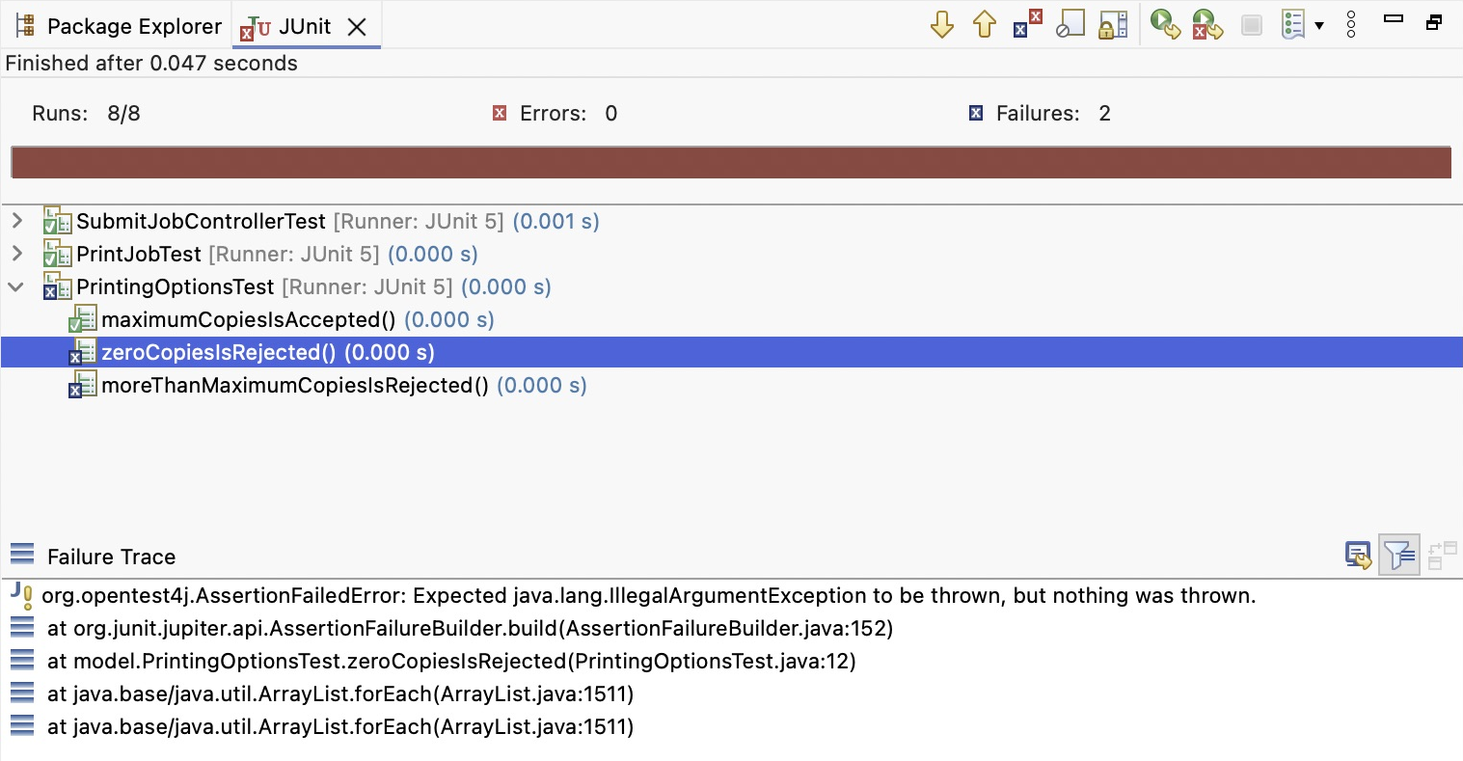
Figure 3 Two failing tests
2. Select a failed test in the JUnit view and read Failure Trace. Double-click the entry naming your test class to locate its assertion. Compare the expected and actual behaviour with the requirement: a failure can mean an error in the application or in the test.
Here, assertThrows expects IllegalArgumentException for 0 and 51 copies. Throwing it would make the test pass; the tests fail because no exception is thrown. PrintingOptions is missing validation. Insert this check at the start of its constructor in src/model/PrintingOptions.java, before assigning the fields:
if (copies < 1 || copies > MAX_COPIES) {
throw new IllegalArgumentException("Copies must be between 1 and " + MAX_COPIES);
}
3. Run all tests again. Expect 8 tests, 0 errors and 0 failures. Rerun the full suite after each change.
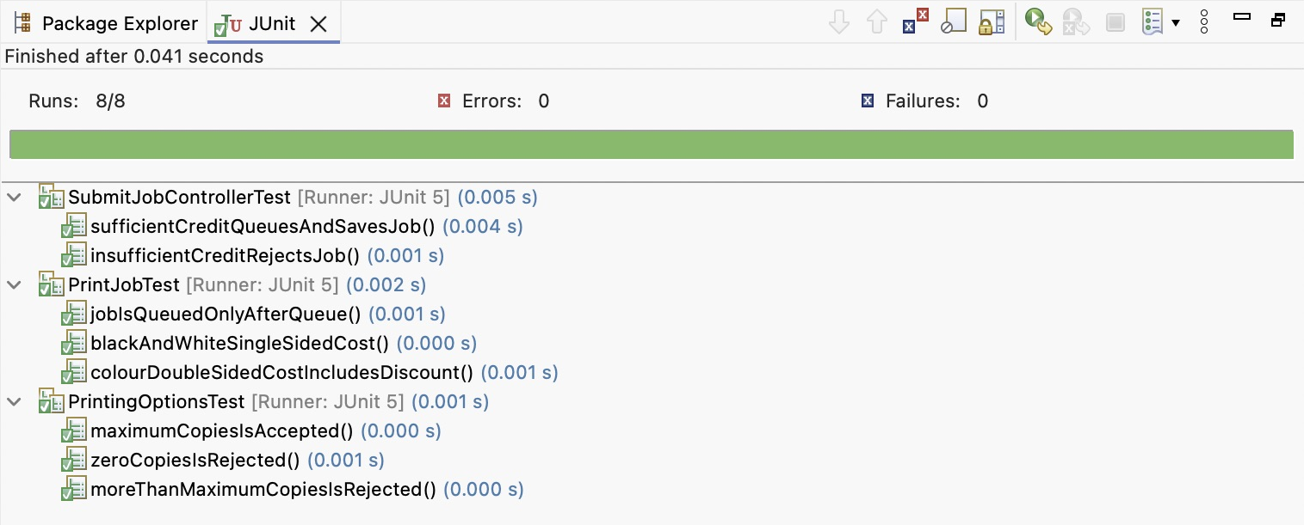
Figure 4 All Part A tests pass

A.4 Find defects with static analysis
Stay in PrintShopLab10. The supplied app.PrintJobReport class contains five planted defects; it is not generated by either analysis tool. Inspect and fix it without running the class. SpotBugs examines compiled Java for bug patterns; SonarQube for IDE examines source code and also reports maintainability suggestions. Their findings overlap but differ.
1. Open Properties > SpotBugs and enable project specific settings. Under Reporter Configuration, set Minimum rank to report to 20 and Minimum confidence to report to Low. Select all categories and set Analysis effort to Maximal if available. Apply the settings.
2. Right-click the project > SpotBugs > Find Bugs. Open Window > Show View > Other > SpotBugs > Bug Explorer. Expand the groups and select individual warnings to read their details and locate the code. Expect four warnings in PrintJobReport; results do not appear in the Console.
3. Open src/app/PrintJobReport.java. Inspect the editor markers and SonarQube On-The-Fly view (Window > Show View > Other > SonarQube).
4. Locate and correct the five planted defects: ignored trim() result, String comparison with ==, loop counter moving the wrong way, integer division, and possible null dereference. Record which tool detects each. Save and rerun analysis after fixes; SpotBugs finds four of these defects, while SonarQube also flags the loop.
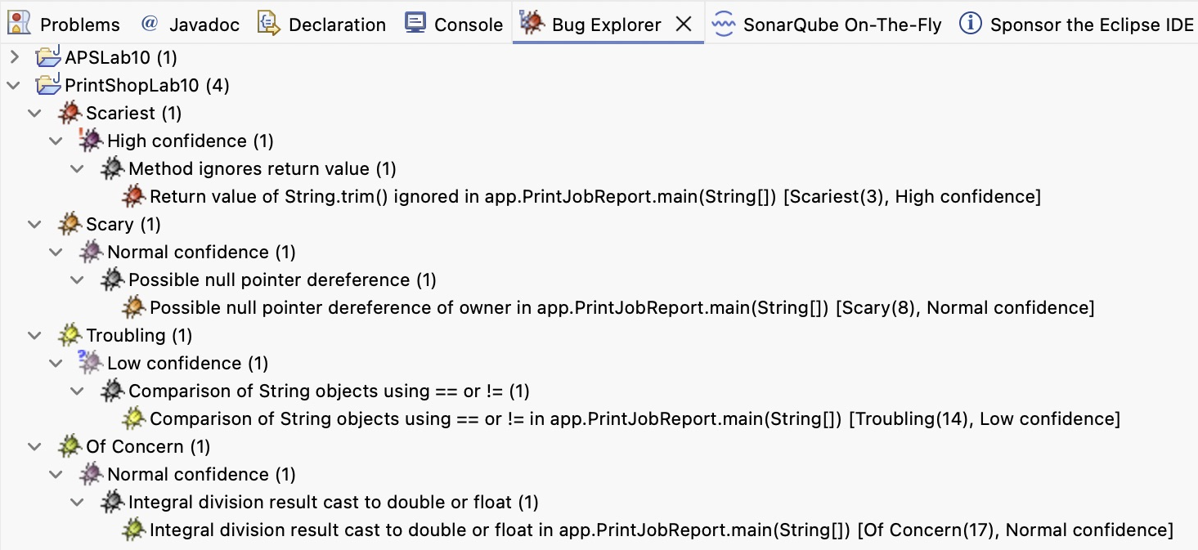
Figure 5 SpotBugs Bug Explorer
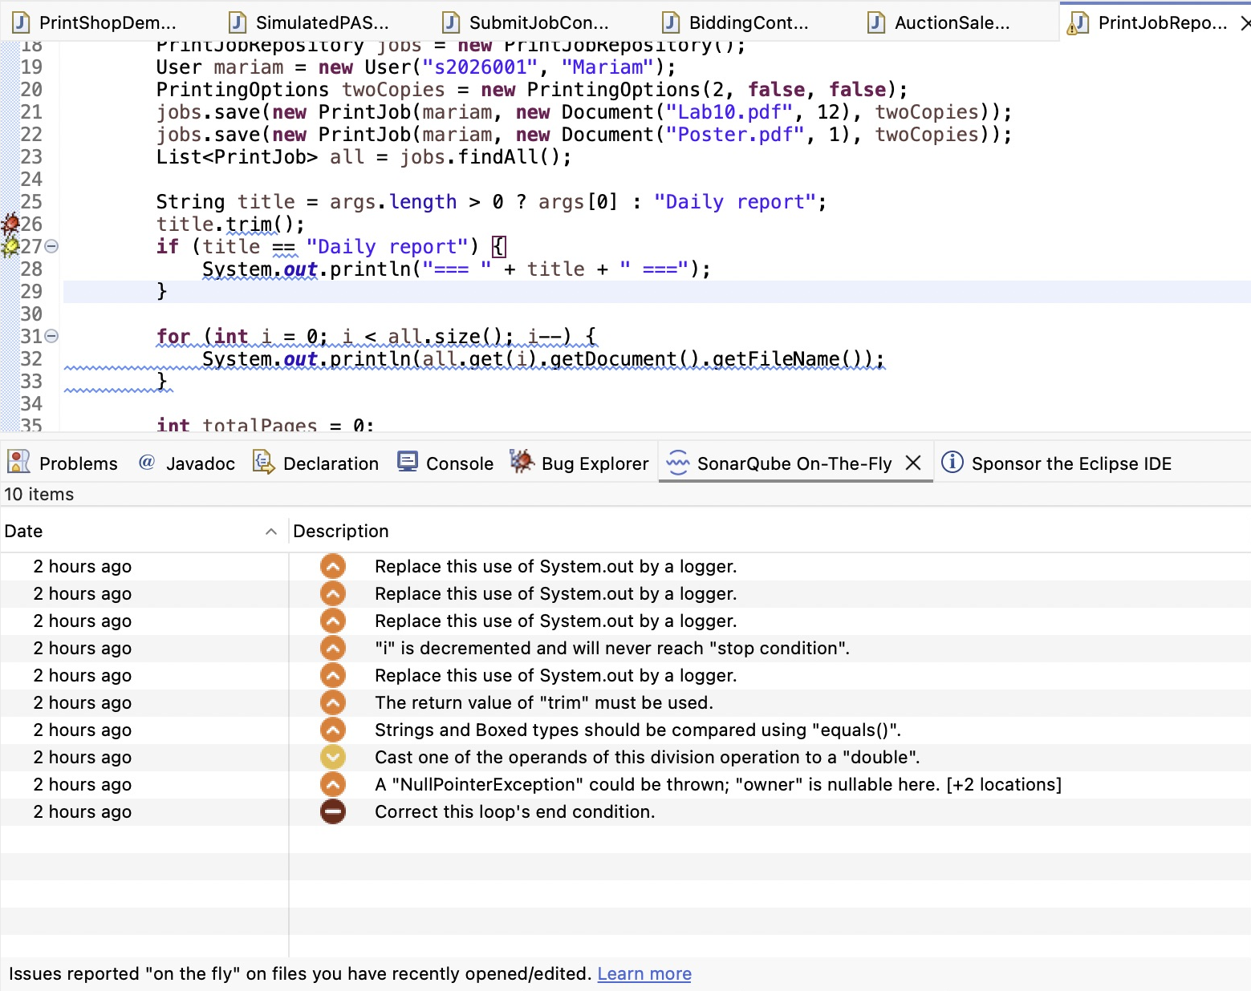
Figure 6 SonarQube for IDE issues
For PrintJobReport alone, the reference Sonar run reports 10 issues before fixes: six messages concern the five planted defects, and four recommend a logger instead of System.out. Project-wide totals may include other files. Logger and record-refactoring suggestions are outside the required Part A fixes; do not change constructor calls that intentionally test exceptions in assertThrows.
Finish A.4 by confirming that the original SpotBugs warnings and Sonar defect messages are gone, then rerun JUnit: expect all 8 tests to pass. Passing tests verify the cases they exercise; they do not prove that every part of the application is defect-free.

Part B All Phones Shop - Individual testing
Individual assessment. You may discuss ideas, but write your own tests. You will test a supplied implementation of UC006 Place bid from the Lab 8 design (Figure 3 and the UC006 diagram reviewed in class); Appendix 2 gives the specification. Download APSLab10 from the course repository and import it as in Part A. Its test folder has the packages model and controller but no tests: you design and write them. The code has not been tested and contains defects.
- Scope. BiddingController receives the AuctionSale and the buyer’s Client directly; they stand for the objects that ItemCatalog.find() and ClientContainer.find() return in Lab 8. Listing items, the catalog and the client registry are outside this lab.
- Assumptions. An auction is open while the current time is before its end time, so a bid at exactly the end time is too late. The first bid must be greater than the starting price. Amounts are in QAR and stored as double.
- Time as a parameter. Operations receive the current time as now instead of reading the clock, so a test can choose any time.
Class (package) | Supplied members
Client, abstract (model) | registrationNo: int, name: String, address: String, bids: List<Bid>; constructor Client(registrationNo, name, address); addBid(bid); getBids(): List<Bid>; getters.
IndividualClient, CorporateClient (model) | Subclasses of Client with a constructor that calls super.
Bid (model) | amount: double, placedAt: LocalDateTime; Bid(amount, placedAt) rejects an amount of zero or less with IllegalArgumentException; getters.
Sale, abstract (model) | Abstract operation describeTerms(): String.
FixedPriceSale (model) | price: double; describeTerms() returns, for example, "Fixed price QAR 1200.00".
AuctionSale (model) | startingPrice: double, endsAt: LocalDateTime, bids: List<Bid>; isOpen(now): boolean; lastOfferedPrice(): double, the starting price when there are no bids; addBid(bid) rejects a late bid (IllegalStateException) or a bid not greater than the last offered price (IllegalArgumentException); describeTerms() returns, for example, "Auction from QAR 800.00, ends 2026-11-20T18:00".
BidResult, enumeration (controller) | ACCEPTED, BID_TOO_LOW, AUCTION_ENDED.
BiddingController (controller) | selectedAuction: AuctionSale; selectAuction(auction, now): boolean (steps 1–2, false for 2.a); getLastOfferedPrice(): double; placeBid(buyer, amount, now): BidResult (steps 3–6, 4.a, 4.b). An accepted bid is added to the auction and to the buyer.
BidReport (app) | summary(auction, buyer, lastResult): String, a short report on one client’s bids. Analysed in B.3; it does not need tests.

B.1 Design test cases from the specification - 25 minutes
- Create Table B1 in lab10-solution.docx using the template below. As in A.2, identify the purpose, requirement source (Appendix 2 step, alternative flow or Part B rule), input or action, and expected result before writing JUnit tests. Choose your own input data.
ID | What we are testing | Requirement source | Input or action | Expected result | Actual result | Pass/Fail
- Write one independent test case for each required condition below, using its ID. You may add further cases (TC-B11 onwards), but they earn no extra marks.
TC-B1 Steps 1–2: selecting an open auction succeeds and shows the starting price as the last offered price.
TC-B2 2.a: selecting an auction after its end time fails.
TC-B3 Steps 3–6: a bid higher than the last offered price is accepted and recorded for both the auction and the buyer.
TC-B4 4.b: a bid equal to the last offered price is rejected and is not recorded.
TC-B5 4.b, resuming at step 3: after a rejected bid, a higher bid is accepted.
TC-B6 4.a: a bid placed after the end time is rejected.
TC-B7 First-bid rule: a first bid equal to the starting price is rejected.
TC-B8 Boundary: a bid one minute before the end time is accepted.
TC-B9 Boundary: a bid at exactly the end time is rejected.
TC-B10 Sale terms: describeTerms() returns the stated text for FixedPriceSale and for AuctionSale.

B.2 Automate the tests with JUnit - 40 minutes
- Write one @Test method per test case in the packages of the test folder. Choose your own test class and method names, and put the test ID in a comment. Apply the setup and assertion guidance in A.3.
- Run all tests and record the Actual result and Pass/Fail of this first run in Table B1. For each failure, use Failure Trace as in A.3 and decide from Appendix 2 and the Part B rules whether the code or the test is wrong. Correct the code in src and record each defect in Table B3: test ID, class and operation, what was wrong, and the correction. Rerun the full suite until all tests pass.
- Add a screenshot of the JUnit view after the corrections, showing all your tests passing.

B.3 Find defects with static analysis - 20 minutes
- Apply the A.4 settings and analysis workflow to APSLab10. app.BidReport contains planted defects that the tests do not reach; inspect and fix it without running it. Some defects are reported by only one of the two tools. In Table B2, record each finding: tool, warning, class and line, and decision (fixed, or accepted with a reason).
- Run the tests again after the fixes. Add screenshots of the Bug Explorer and the SonarQube view before the fixes.

Submission requirements
10 minutes. Open the CMPS310 GitHub repositories and select your own repository. Submit the items below inside a folder named Lab 10 Implementation and Testing, using the individual repository workflow from Lab 4. Part A is not submitted.
Item | Required contents
lab10-solution.docx | Name and student ID; Tables B1, B2 and B3; the JUnit and static analysis screenshots.
APSLab10 folder | The APSLab10 project with your test classes and corrected src. Do not include the bin folder.

Commit and push, then check that the files open from your repository. Milestone 2 asks for test cases, test data, expected and actual results and pass/fail decisions in the same form as Table B1.

Assessment criteria (10 points)
Criterion | Points
Test cases TC-B1 to TC-B10 cover the required conditions, each traced to Appendix 2 or a Part B rule, with input data and expected result | 3
JUnit tests automate every test case with correct assertions; first-run actual results and Pass/Fail recorded | 3
Defects found by the tests recorded in Table B3, explained against the specification and corrected; all tests pass | 2
BidReport findings recorded with the tool that reported each and a justified decision; tests rerun after fixes | 1
Readable tests, screenshots and complete submission | 1

Further reading: JUnit 5 User Guide
SpotBugs: using the Eclipse plugin
SonarQube for IDE: Eclipse

Appendix 1 UC001 Submit print job specification
Use case ID: | UC001 Submit print job
Brief description | A user submits a document with printing options. The Print Shop accepts the job if the user has sufficient credit and queues it for printing.
Primary actors | User (Student or Staff member).
Secondary (supporting) actors | PAS, through Print Shop UC006 Check sufficient credit.
Trigger | The user chooses to submit a print job.
Preconditions | The user is identified to the Print Shop (assumption).
Postconditions | The job is recorded with its document, printing options, submitting user and status queued.
Main Success Scenario
Actor Action | System Response
1. The user uploads a document.
 | 2. The system asks for the printing options.
3. The user selects the number of copies, colour or black-and-white, and single- or double-sided printing.
 | 4. The system calculates the printing cost.
 | 5. The system includes Print Shop UC006 Check sufficient credit for the printing cost (see 5.a).
 | 6. The system records the job with status queued.
 | 7. The system confirms to the user that the job is accepted.
Alternative flows:
5.a. Insufficient credit: the system rejects the request and informs the user. No job is recorded and the use case ends.

Appendix 2 UC006 Place bid specification
Use case ID: | UC006 Place bid
Brief description | A registered client offers a price for an item on auction. APS accepts the bid if the auction is still open and the bid is greater than the last offered bid, and records it in the client’s registration.
Primary actors | Client, acting as buyer.
Secondary (supporting) actors | None.
Trigger | The client selects an item on auction to bid on.
Preconditions | Login has been checked outside APS. The client has a registration. The item is displayed in the catalog for auction.
Postconditions | The bid is recorded in the client’s registration and is the last offered bid for the item.
Main Success Scenario
Actor Action | System Response
1. The client selects an item on auction.
 | 2. APS checks that the auction end time has not passed and shows the last offered bid (see 2.a).
3. The client submits a bid price.
 | 4. APS checks that the auction end time has not passed and that the bid is greater than the last offered bid (see 4.a and 4.b).
 | 5. APS records the bid in the client’s registration as the last offered bid.
 | 6. APS confirms the accepted bid to the client.
Alternative flows:
2.a. Auction ended: APS informs the client that the auction has ended. No bid is recorded and the use case ends.
4.a. Auction ended before the bid was submitted: as 2.a.
4.b. Bid not greater than the last offered bid: APS rejects the bid and informs the client. The use case resumes at step 3.

